**HKU SPACE Community College**

**Associate Degree Programme**

**2022 - 2023**

# **Project on Knowledge Products Development**

Final report

“Fingerprint Door Lock”

Kafle Manis 20188059

Wan Tsz Ho 20186496

Khan Junaid 20167731

**Contents**

**1 Introduction**

1.1 Project description

1.2 Project objectives

1.3 Development Process

**2 Detail requirement specifications**

2.1 Requirements

2.2 Gantt chart

**3 Detail design specifications**

3.1 Hardware

3.2 Software

3.3 Operational flow

**4 Evaluation**

4.1 Testing methodology

4.2 Test data

4.3 Test results

**5 Conclusion**

5.1 Critical review of the project results

5.2 Further studies/development

5.3 Learned knowledge

5.4 Reflection

**6 Acknowledgement**

6.1 References

6.2 Appendices

**1. Introduction**

**1.1 Project description**

A scanner and authentication tool for fingerprints is the fingerprint recognition module. The module processes data using an Arduino microcontroller, and it takes fingerprint images using an optical sensor.

In addition, there were a total of 1071 and 646 burglary crimes in 2021 and 2022 respectively. (HKPF, 2022). Therefore, the product is aimed towards citizens residing in residential areas with security problems especially within old buildings. In addition, buildings with a high degree of vulnerability to theft crime such as banks, database centers and many more. Thus, the purpose of this product is to nullify the problem and provide an optimal solution to counter the perpetrators.

**1.2 Project objectives**

The objective of this project is to design and construct a functional door lock system that utilizes a fingerprint scanner for user identification. And suitable for everyone, especially those who require high-level security, such as individuals residing in high-risk areas prone to robbery and theft, as well as database centers.

Our specific targets are as follows:

1. To create a small-scale door equipped with a fingerprint scan sensor that can accurately identify authorized users and grant them access.
2. To ensure that the device is easy to use, with a simple and intuitive interface that requires minimal training to operate.
3. To make the device quick and efficient, with fast response times and minimal delays in granting access.
4. To ensure that the device is accurate, with a low false acceptance rate and false rejection rate, to minimize the risk of unauthorized access.

**1.3 Development process**

In the part of the design, we developed the conceptual design of the fingerprint door lock, including the hardware and software components.

We used Arduino as the platform for the hardware, and we developed the software using the Arduino Integrated Development Environment (IDE), which allowed us to program the device using Arduino programming language which is a simplified version of C++.

We built the hardware components of the fingerprint door lock, including the fingerprint sensor, a microcontroller(Arduino Nano), a relay module, and a solenoid lock. We also wrote and tested the software code to control the device and interface with the fingerprint sensor.

**2 Detail requirement specifications**

**2.1 Requirements**

Functional requirements:

* Capture fingerprint images
* Keep a record of fingerprints.
* Verify fingerprint authenticity using saved fingerprints.
* Depending on the outcome of the authentication, control an output device, such as a lock or an LED.

Performance requirements:

The fingerprint recognition module must be able to validate fingerprints in a timely and accurate manner. The following performance criteria must be fulfilled:

* The time needed to capture a fingerprint should be under a second.
* Less than 2 seconds should pass during authentication.

Security requirements:

The fingerprint recognition module should offer a high level of security. The following security prerequisites must be fulfilled:

* Fingerprints that are kept should be secured against unwanted access with encryption.
* High degree of accuracy to minimize unwanted access

Maintenance requirements:

The fingerprint recognition module should be simple to maintain. The following upkeep needs must be satisfied:

* It should be simple to upgrade or reprogram the module for upcoming enhancements or bug patches.
* It should be made with durable elements to avoid unnecessary frequent maintenance/damage
* It should be kept in a safe environment to ensure the device is safe. Thus, low maintenance.

**2.2 Gantt chart**

[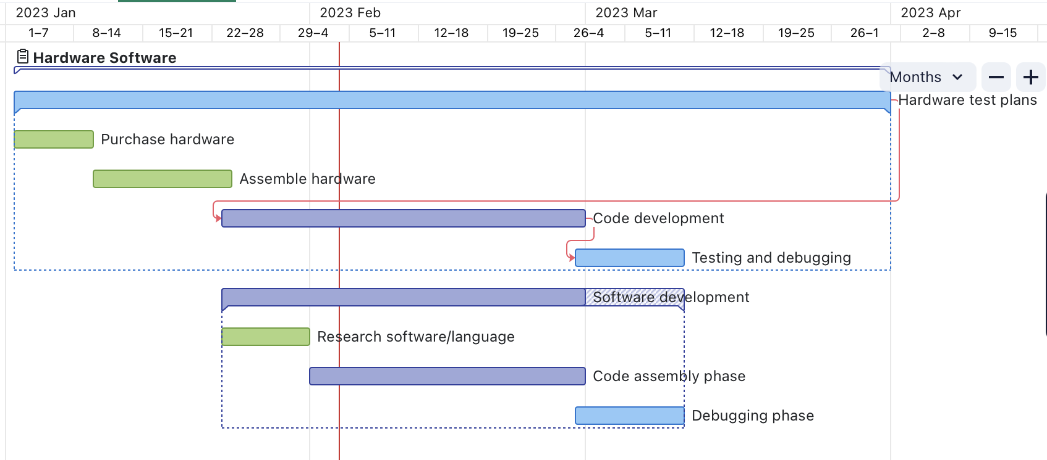](https://www.wrike.com/frontend/ganttchart/index.html?snapshotId=xYwSQ59MwgMeOzPkcisEfxkA4LHbhhj2%7CIE2TSNBUG4ZTALSTGIYA)

The Gantt chart provided is the timeline of our project being carried out throughout the semesters to ensure all the requirements were met.

First and foremost, hardware components were researched extensively to make sure the most compatible and accurate components were purchased. After the delivery of all the essential components, the group was divided into 2 to apply division of work including the software department and the hardware department. The hardware department was responsible for the assembly of the modal while the software department was responsible for the development of code and interfaces. Then, both of the divisions worked together on the testing and debugging phase of the project. Any discrepancies were investigated and efficiently resolved.

**3 Detail design specifications**

**3.1 Hardware**

The fingerprint recognition module must be constructed using the following hardware elements:

* Arduino microcontroller: Arduino nano *(Figure 1)*
* Fingerprint sensor module *(Figure 1.1)*
* (Optional) Buzzer or LED output device. *(Figure 1.3)*
* Solenoid lock *(Figure 1.4)*
* Relay module *(Figure 1.2)*
* Wires (For connecting: GND, TX, RX, VCC)

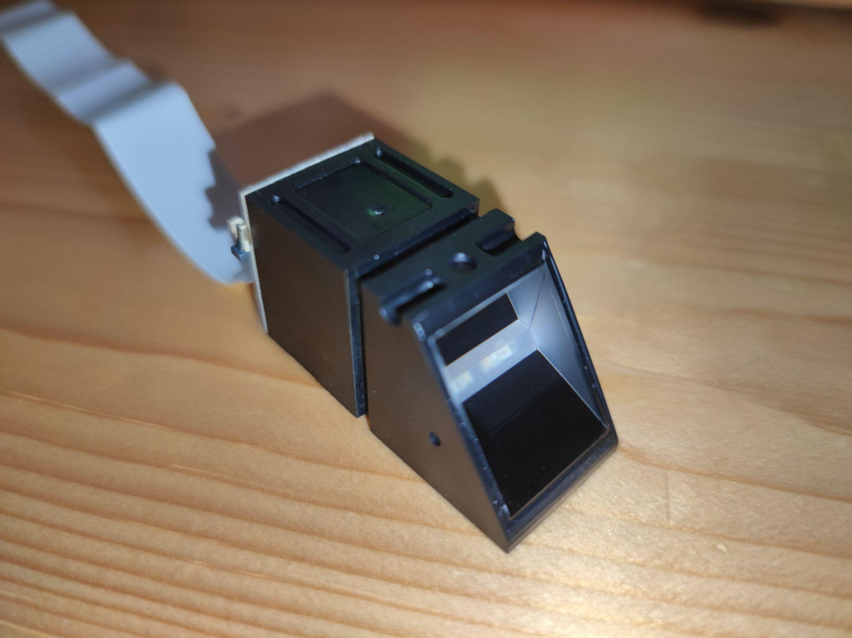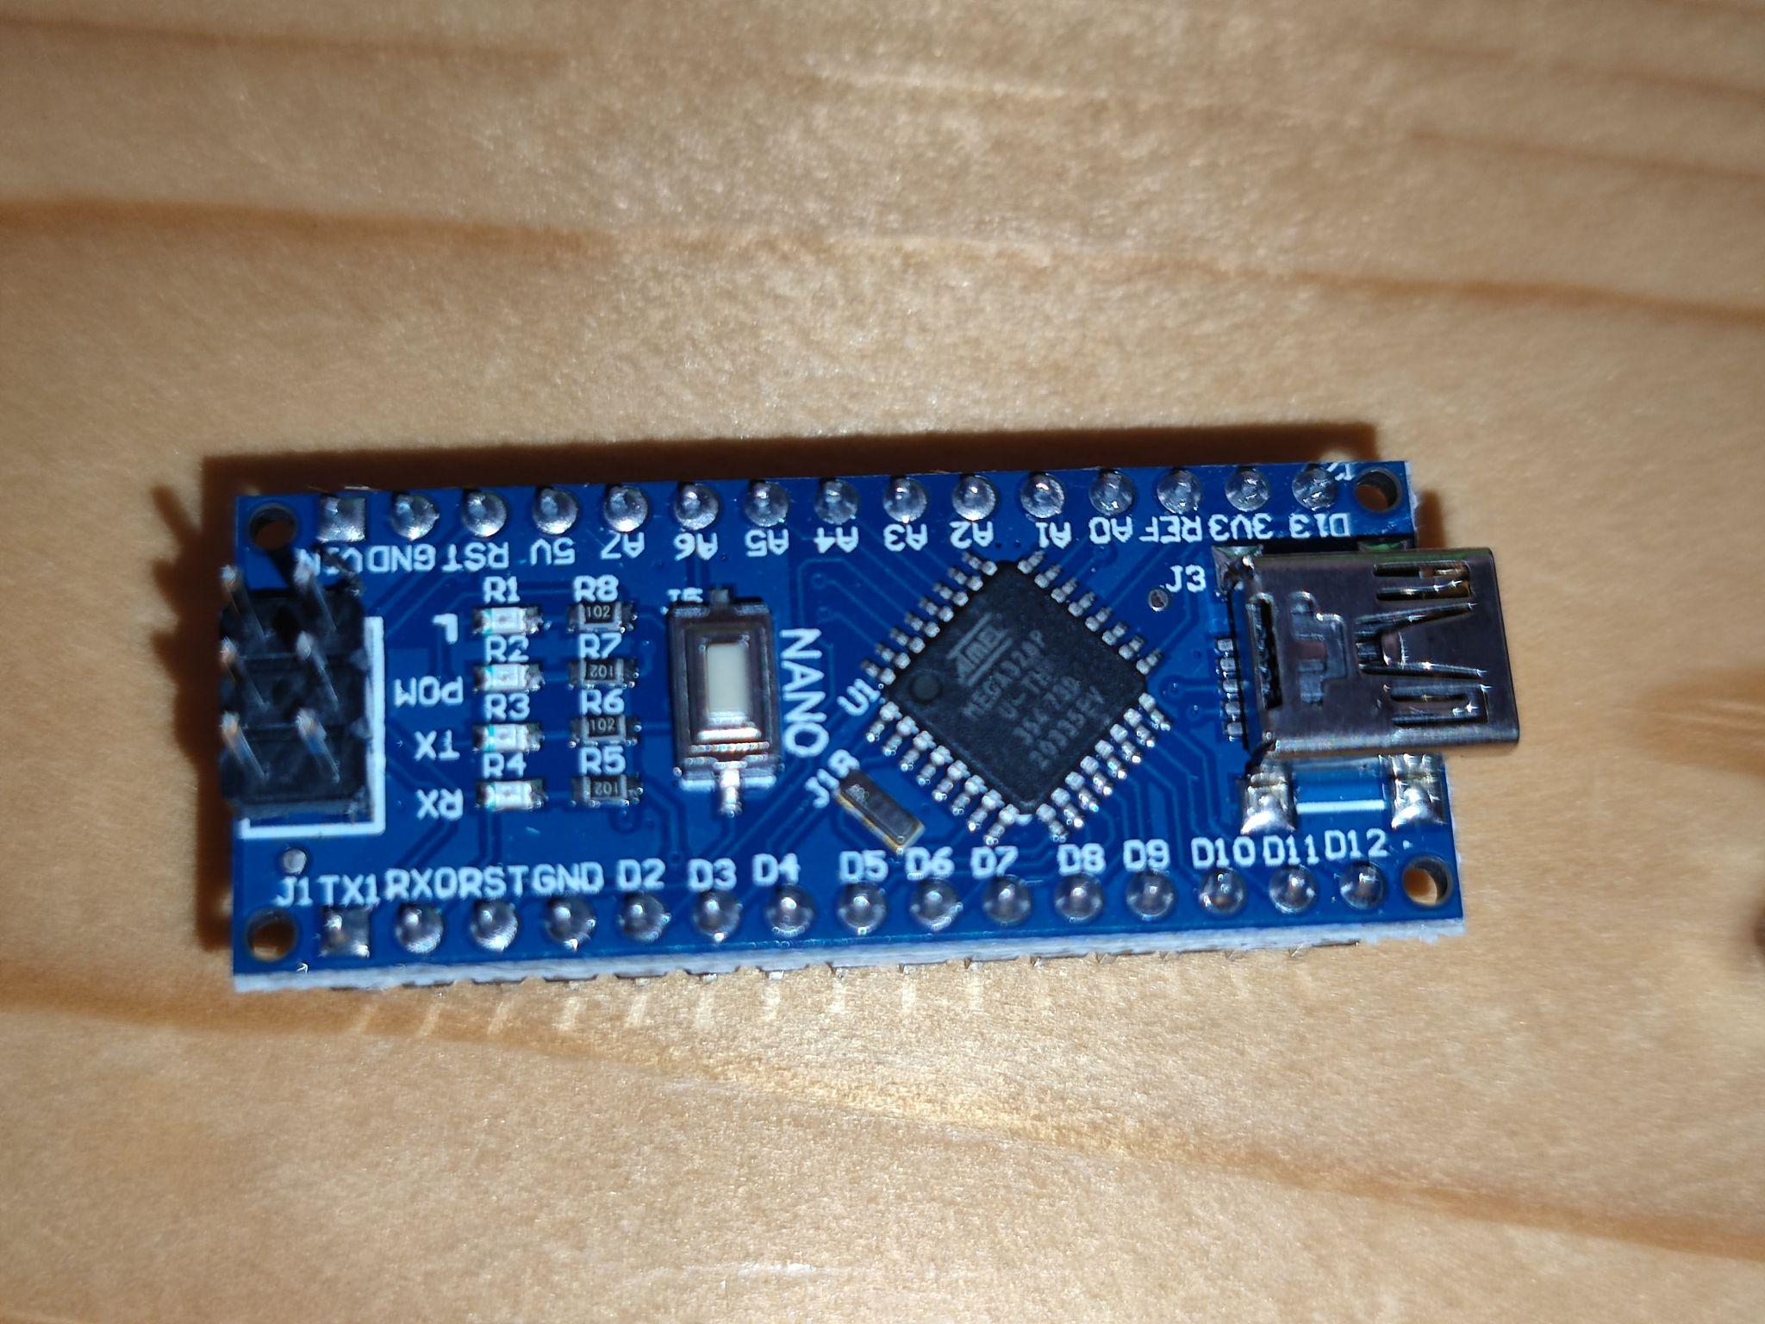

*(Figure 1.0: Arduino NANO) (Figure 1.1: Fingerprint Scanner)*

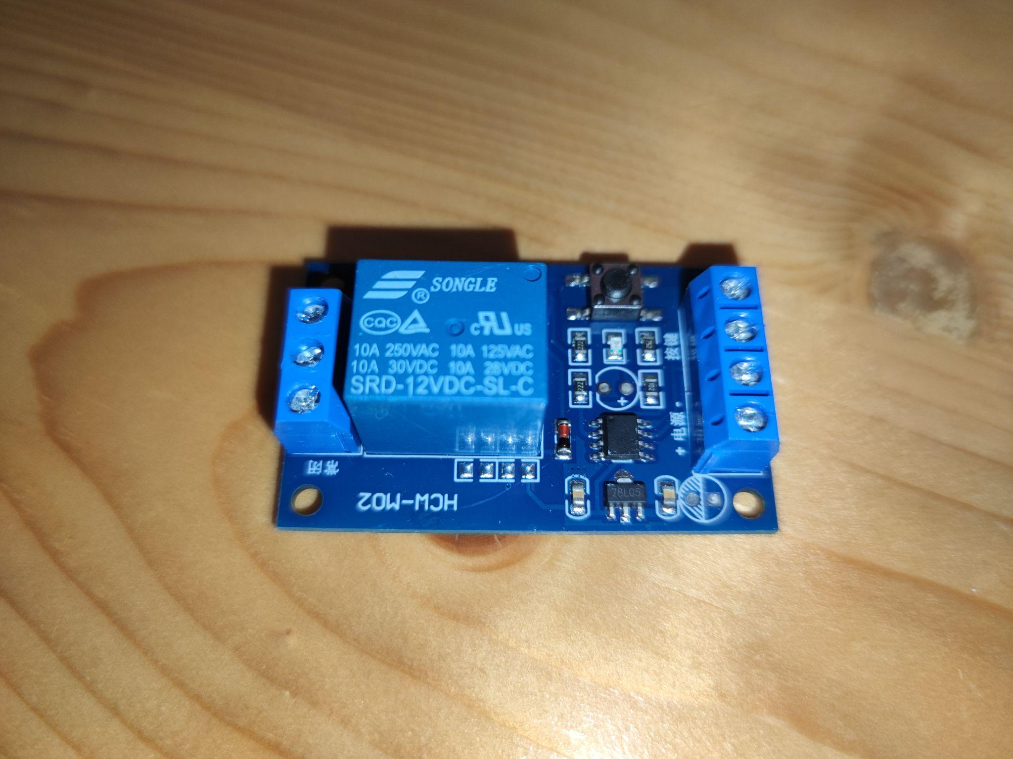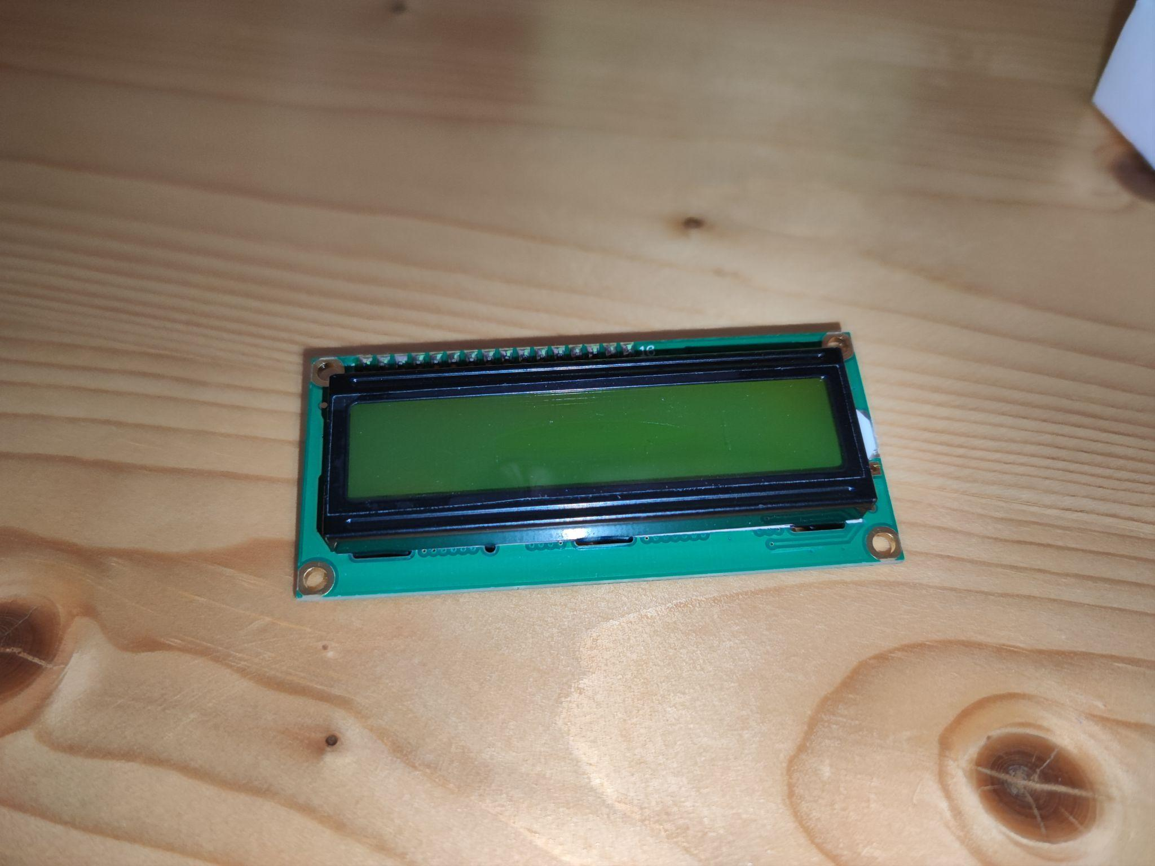

*(Figure 1.2: Relay Module) (Figure 1.3: display module)*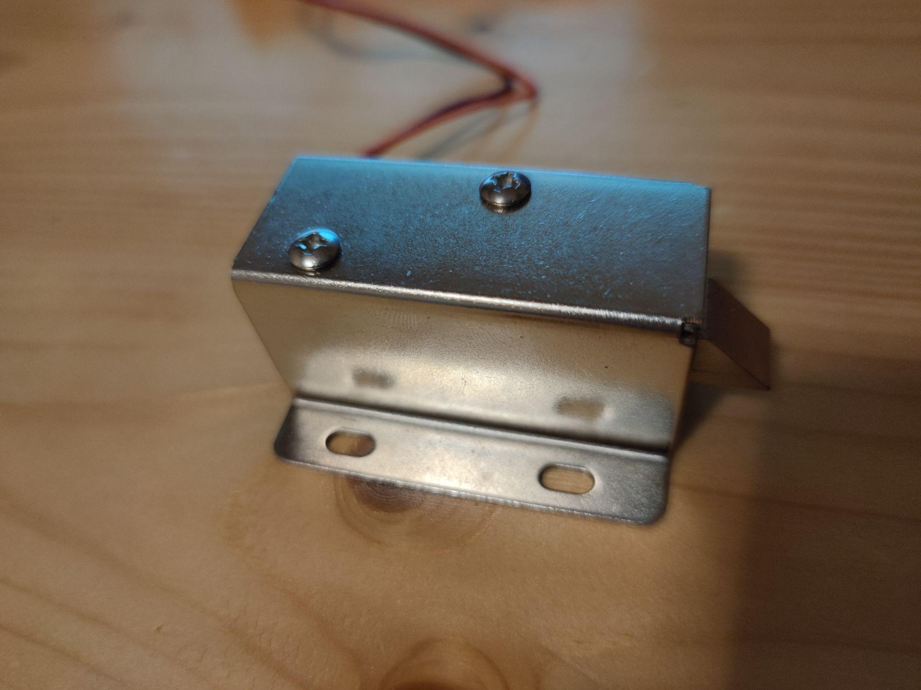

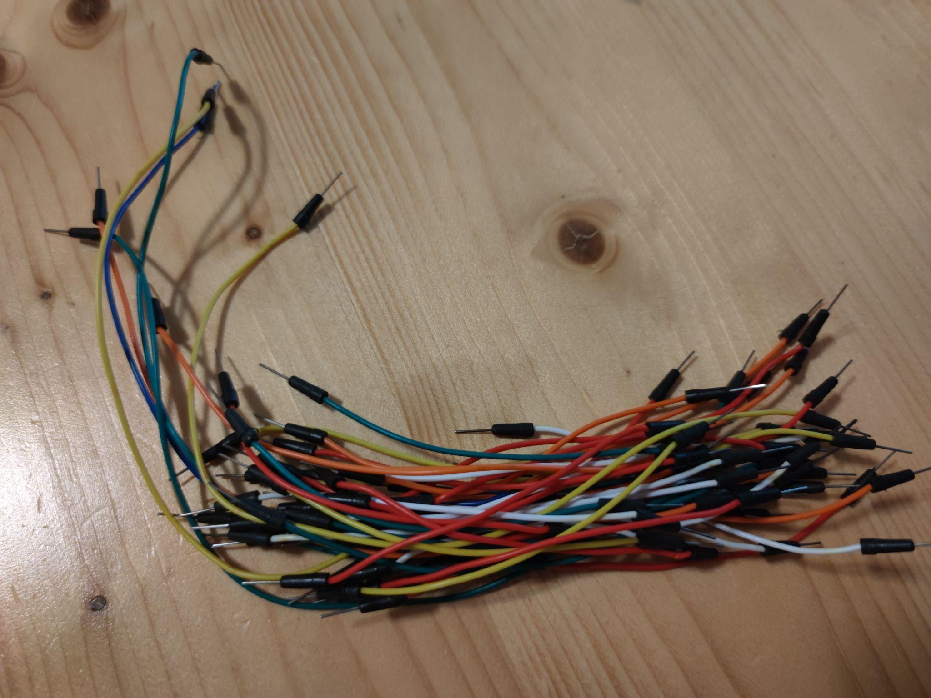

*(Figure 1.4: Solenoid lock) (Figure 1.5: Wires)*

**3.2 Software**

The fingerprint recognition module has the following software elements:

* Integrated Development Environment (IDE) for Arduino.
* Adafruit Fingerprint Sensor Library, for example, is a fingerprint recognition library for Arduino.
* The output device is controlled by the software.

**3.3 Operational flow**

By placing their finger on the sensor and going through the enrollment process, the user can enroll with their fingerprint. If needed, several fingerprints may be enrolled. The user presses their finger against the sensor to validate a fingerprint. A fingerprint image is captured by the sensor, which then matches it to the registered fingerprints stored in the Arduino's memory. In the event that the authentication is successful, the Arduino signals the relay module to turn on the solenoid lock, unlocking the door or object. The Arduino provides a signal to the relay module to disable the solenoid lock if the authentication is unsuccessful, keeping the door or object locked. A buzzer provides the user with feedback on the authentication outcome. If the authentication is successful, the buzzer will open. The buzzer will remain at its default position if the authentication is unsuccessful. The user can turn off the fingerprint recognition module once they are done using it. The module will save the registered fingerprints in its memory and begin initialization the next time it is powered on. The fingerprint recognition module completes the following processes, in order: initialization, fingerprint enrollment, fingerprint authentication, output control, feedback, and power-off. The user can register numerous fingerprints, and the module uses a buzzer to inform the user of the success of the authentication. A data flow diagram has been provided below for reference to the operational flow of the project.

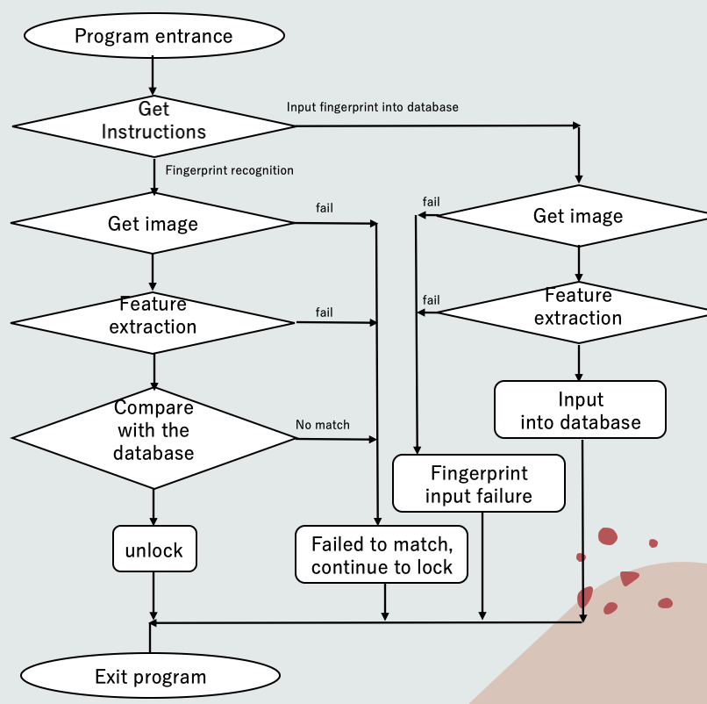

*（Figure 2.0: Fingerprint recognition flowchart）*

**4 Evaluation**

**4.1 Testing methodology**

To make sure the fingerprint device functions correctly and without any problems, testing methodology was crucial during development. Our group understood the value of performing exhaustive testing at each stage of the development process to find and fix any potential problems.

In order to do this, we put in place a testing procedure that involved inspecting each stage of the device assembly. This process allowed us to identify any issues or discrepancies, ensuring that the device was constructed in a proper and efficient manner. We also tested the links between the hardware and software components to ensure that they were correctly established and working seamlessly.

Our primary testing methodology involved conducting separate tests to evaluate the fingerprint recognition functionality, fingerprint enrollment capability, and fingerprint recognition accuracy of the fingerprint recognition door lock. Regarding the fingerprint enrollment aspect, I will be testing the device's ability to accurately recognize and enroll different fingerprints. To accomplish this, I will be conducting tests using various fingers, including ones that have already been enrolled(e.g. thumb and forefinger) and those that have not, to ensure that the device does not mistakenly recognize the unenrolled fingerprints.

To ensure reliable and consistent results, each test will be run multiple times. Any issues or discrepancies will be identified through analysis of the test data, and necessary measures will be taken to address these concerns. Early detection and resolution of issues will enable us to produce a better product.

**4.2 Test data**

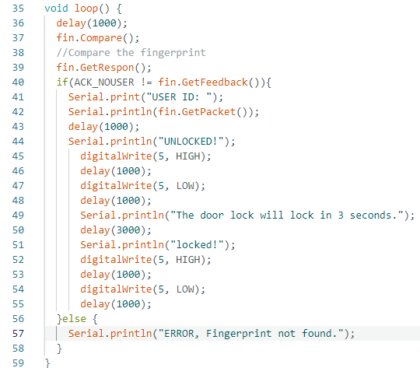

*(Figure 2.0: Arduino codes in fingerprint_door_lock)*

In the arduino code*(Figure 2.0)*, if a successful fingerprint match is made, it will output the User ID and “UNLOCKED!”. The door lock will unlock. If it fails, it will output "ERROR, Fingerprint not found.".



*(Figure 2.1: Arduino codes Line 6 in fingerprint_door_lock)*

Now I set the NEW_USER_ID as 1 to inputted thumb fingerprint into it*(Figure 2.1)*.

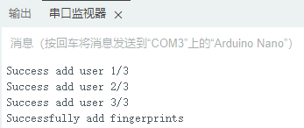

*(Figure 2.2: information in Serial Monitor)*

Successfully inputted thumbprint into it from the serial monitor*(Figure 2.2)*. Next, to repeat the process and input the index finger and set the NEW_USER_ID as 2*(Figure 2.3)* .



*(Figure 2.3: Arduino codes Line 6 in fingerprint_door_lock)*

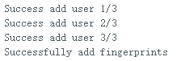

*(Figure 2.4: information in Serial Monitor)*

Successfully inputted too*(Figure 2.4)*. Next, will test it with the thumb.



*(Figure 2.5: information in Serial Monitor)*

As we can see from the serial monitor*(Figure 2.5)*, it has successfully recognized the thumbprint and identified the User ID as 1.Next, will test it with the index finger.



*(Figure 2.6: information in Serial Monitor)*

It also has successfully recognized the index fingerprint and identified the User ID as 2*(Figure 2.6)*. Next, will test it with the other fingers that were not previously recorded.

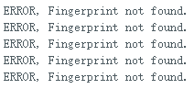

*(Figure 2.7: information in Serial Monitor)*

From the Serial Monitor, The door lock did not open.

**4.3 Test results**

The fingerprint door is designed to allow access to a secured area only to individuals whose fingerprints have been pre-registered in its database. When a registered finger is scanned, the device recognizes it and unlocks the door in 1 seconds. The door lock remains open for 5 seconds before returning to lock*(Figure 2.0)*.

If an unregistered finger is scanned, the device does not open, no matter how many times the finger is scanned*(Figure 2.7)*. When it successfully identifies the registered user, the door lock will quickly unlock. This feature ensures that only authorized individuals can gain access to the secured area. The device appears to be operating flawlessly from the user's point of view because it is successfully carrying out its intended purpose of granting access to only authorized individuals.

Overall, this fingerprint door ensures that only those whose fingerprints have been pre-registered can enter, making it a dependable and effective method of securing access to a restricted area. Any security breaches are also avoided by its quick response time and brief open duration.

**5 Conclusion**

**5.1 Critical review**

In this report, we have outlined the design and implementation of a fingerprint door lock system using Arduino. While our project has demonstrated a functional and secure access control system, there is always room for improvement and expansion. In this section, we will discuss potential areas for further studies and development to enhance the capabilities and features of our fingerprint door lock system.

**5.2 Further studies/development**

Our project relies on the fingerprint recognition capabilities of the fingerprint sensor. However, there is always room for improvement in the accuracy and speed of fingerprint recognition algorithms. Further research and development could be conducted to explore alternative algorithms or to optimize the existing algorithm for better performance.

In the future, we can also incorporate a mobile application or web-based interface for remote access and control of the fingerprint door lock system could provide added convenience and flexibility for users. This would allow users to grant temporary access to guests or service providers, monitor access history, and receive notifications for security events.

As organizations/companies grow and expand, the need for a scalable and modular access control system becomes increasingly important. Further studies could investigate ways to make our fingerprint door lock system more easily adaptable to different environments and capable of accommodating a larger number of users, doors, and access points.

**5.3 Learned knowledge**

Throughout the development of our fingerprint door lock using Arduino, we gained a lot of understanding of several key concepts related to biometric security and embedded systems. We have learned the fundamental principles and implementation methods of fingerprint recognition.

We use Arduino as the development platform because the boards are designed to be easily expandable, with a wide range of add-on modules available. However, all of us had no experience with programming Arduino. Through trial and error, research, and collaboration, we gained a strong foundation in Arduino programming, including basic syntax, control structures, and functions.

We also gained a deeper understanding of embedded systems and the challenges involved in designing and implementing hardware and software components for fingerprint door lock. We learned about the importance of testing and debugging, as well as the need for modular design to facilitate future upgrades and maintenance.

In addition, we have acquired important teamwork abilities that have facilitated effective collaboration and helped us accomplish our objectives.We clearly define roles and responsibilities and use effective communication. Throughout the project, we made a conscious effort to support one another, whether it was by offering advice on technical matters or comfort during trying times. We also regularly evaluated our progress against our goals and adjusted our plans as needed. This helped us to stay on track and make sure we were making progress toward our objectives

**5.4 Reflection**

This project not only allowed our team to apply and expand our technical skills but also to better understand the importance of collaboration and effective communication in creating a useful and innovative product.

In future work, our team could explore implementing additional security features, such as two-factor authentication, to further enhance the lock's protection. Additionally, integrating IoT capabilities could allow for remote access and monitoring, which would enhance the user experience.

Overall, the Knowledge Products Development subject has been an invaluable opportunity to apply our skills and knowledge to a real-world project. Through our fingerprint door lock project, we have gained a deeper understanding of the complexities involved in product development and the importance of collaboration, communication, and continuous improvement.

**6 Acknowledgement**

We feel very thankful that Mr. Louis has given in a lot of efforts to encourage us in learning. Moreover, the guidance provided and the feedback during the class is useful for us to solve problems when we are doing the project, such as designing the model and other elements of the project.

**6.1 References**

1. Hong Kong Police Force. (2022). *Crime statistics comparison*. Crime Statistics Comparison | Hong Kong Police Force. Retrieved February 4, 2023, from <https://www.police.gov.hk/ppp_en/09_statistics/csc.html>
2. *UART Fingerprint Reader UserManual*. <https://www.waveshare.com/w/upload/6/65/UART-Fingerprint-Reader-UserManual.pdf>

**6.2 Appendices**

File: fingerprint door lock.ino (The main arduino file)

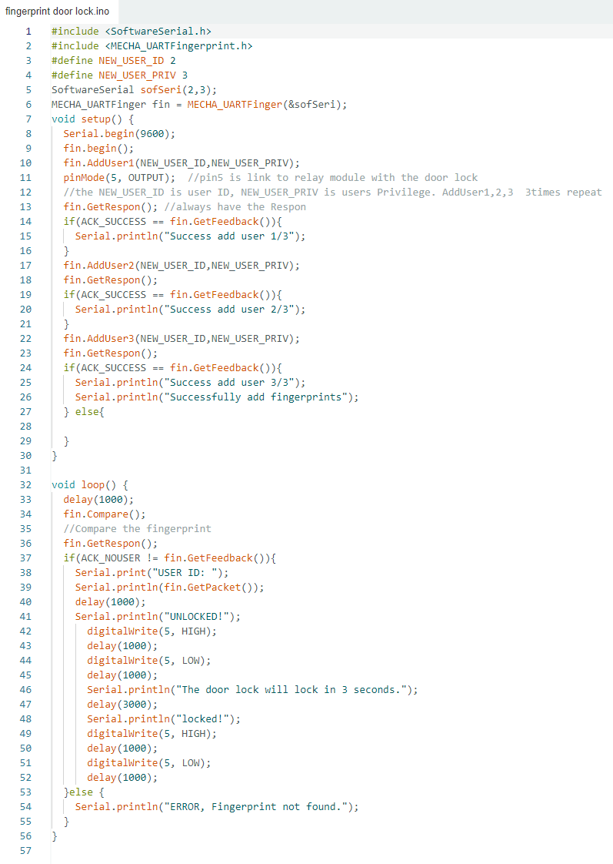

**File: MECHA_UARTFingerprint.cpp (The source file)**

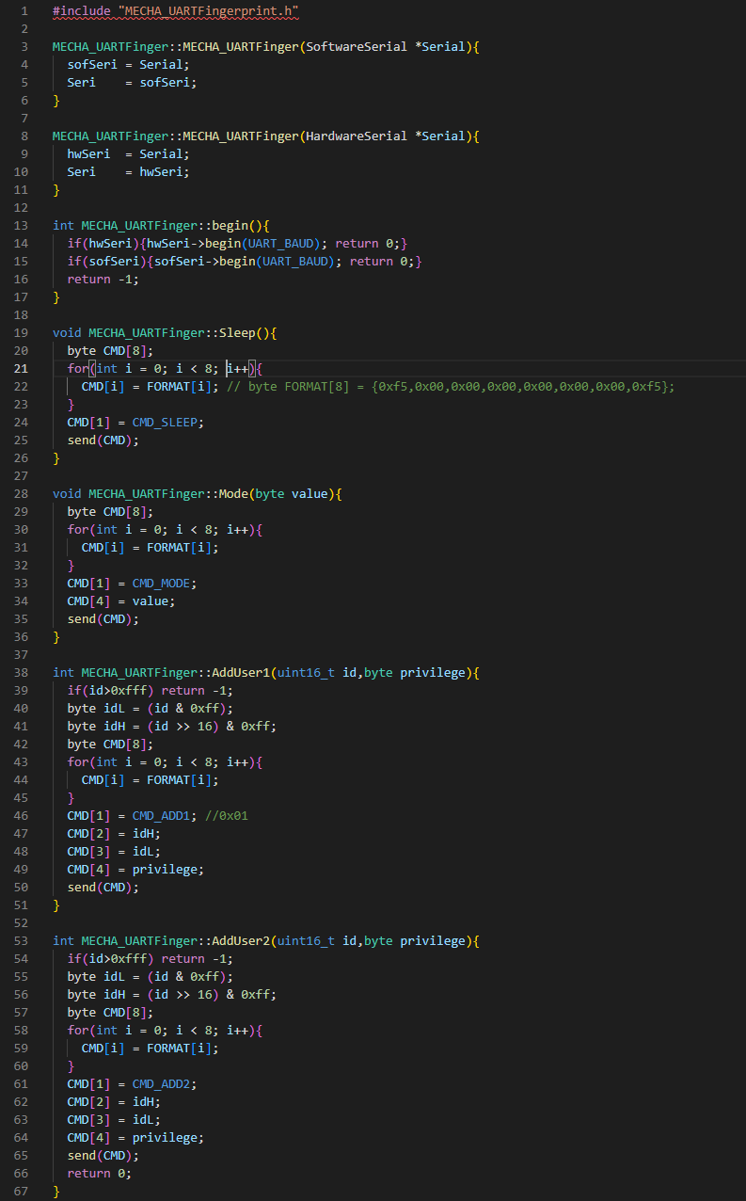

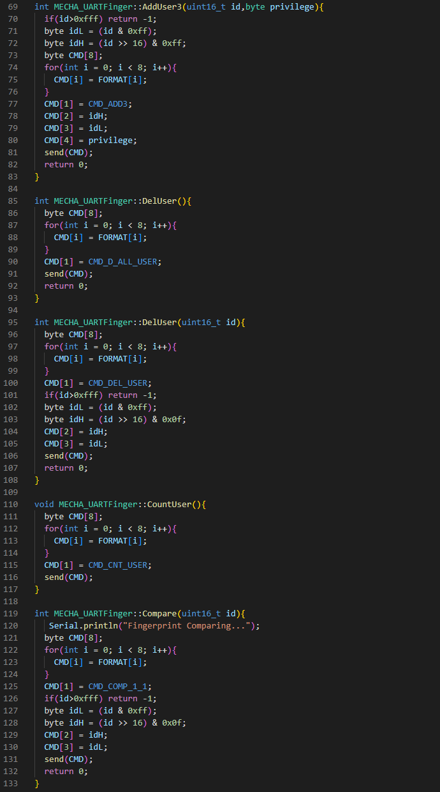

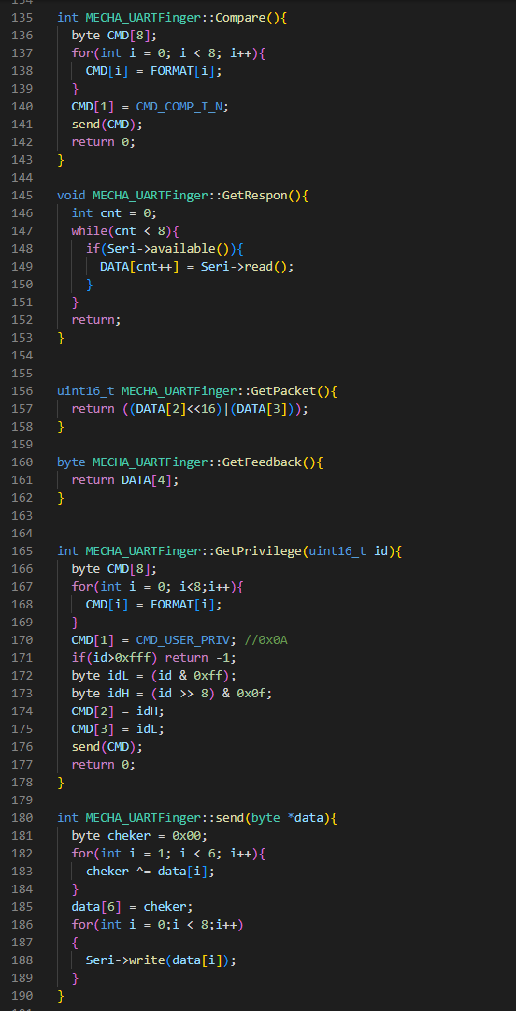

**File：MECHA_UARTFingerprint.h（the header files）**

